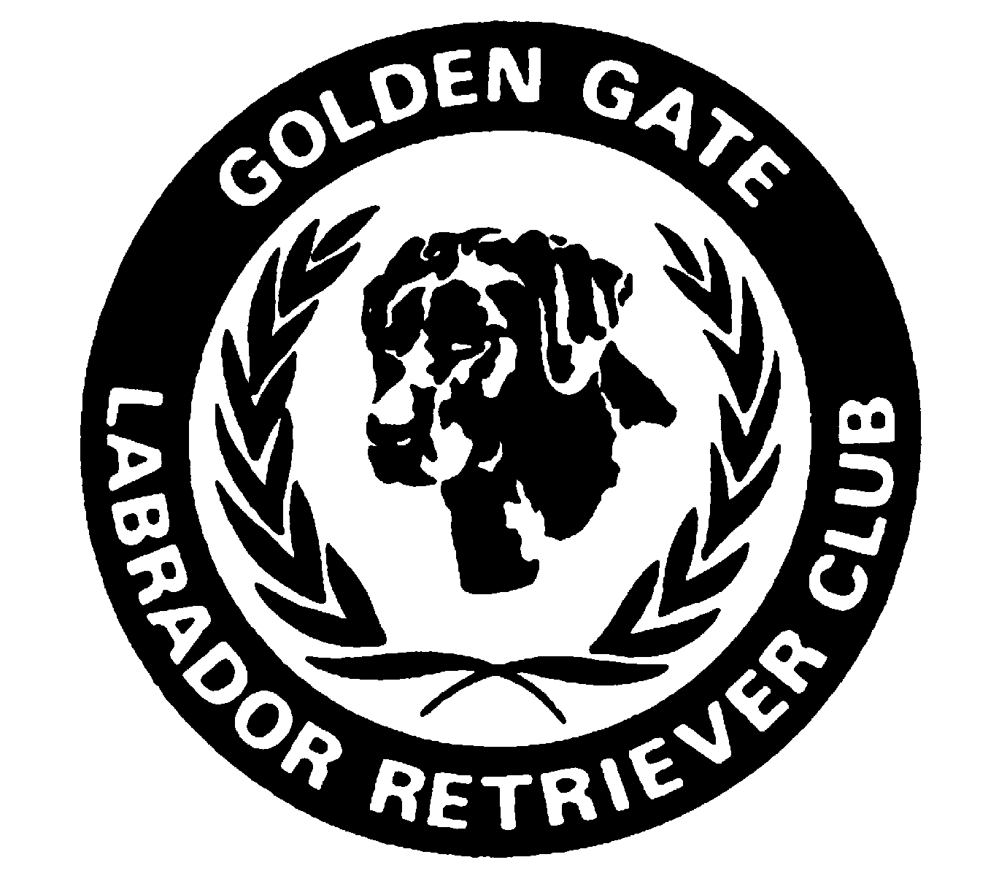  G |  | GGLRC 2021 4th Quarter www.gglrc.org

PRESIDENT’S MESSAGE – Vivian Poole
Looking forward AND looking back. Ruminating on the “Specialty” I had an interesting conversation with a long-time dog club friend the other day about how things have changed over the last decade or two for dog club memberships, events, and participation. You see, I only started “showing” and trying my hand at field training Labs within the last 15 or so years. I was shocked to learn that in the 80 and 90’s, most CA specialties had entries of 400 and more! In those days there were only two Specialty clubs in CA, we currently have seven.

As the major clubs started fractioning off to smaller and more geographically recognized clubs, all clubs suffered shrinking memberships and club participation. Over the years, rising entrance fees, timing, and travel expenses resulted in many participants having to choose between one club’s specialty or another. Today, some clubs don’t have large enough specialty entries to qualify for five-point majors. Also, with so many separate shows, it has become challenging to find judges that aren’t overused.

It’s not just Labrador clubs, but across the board, dog clubs are attracting fewer members resulting in declining participation and struggling to stay viable. WE are all in the preverbal “same boat”. What are the potential solutions and what are the hurdles to overcome?

I am usually the looking forward type of person, but I wonder if it makes sense to consider transitioning back to fewer CA Labrador clubs. We might combine with a club geographically or simply because of financial viability. This merging of clubs could result in being able to put on bigger shows, more variety of events, and increased memberships. I feel this is a conversation worth having with each other and our sister clubs.

Winding up my first year as your club president, I want to thank everyone who has offered their time and talents, showed up and contributed to this year’s planning and putting on club activities and events. We could not survive as a club without you! I am especially grateful to the board and officers for their steady commitment and support.
No one can deny these past couple of years has been tough on gatherings requiring us all to rethink our activities and participation in group events.

Here’s to looking forward to a fresh new year and seeing you all in 2022. Wishing everyone very safe and Happy Holidays!

Warmly,
Vivian

*******************************************************
GGLRC 2021 OFFICERS AND BOARD MEMBERS
Officer Members
- President - Vivian Poole
- Vice President – Melinda Grosch
- Treasurer – Terri Herigstad
- Secretary – Connie Holms

Board Members
- Allen Garfinkle
- Catherine Lewis
- Lauren Rice-Springs
- Kim Sweetnam
- Sharon Scharff-Ventura

GGLRC OTHER CONTACTS:

Newsletter Editor:
Lorrie Bellows email: loralie@mlbellows.com*
Membership:
Kim Sweetnam email: sweetnamk@aol.com
Webmaster:
Elaine Nusser email: en@winterfelllabradors.com

******************************************************
GGLRC 2022 MEMBERSHIP DUES

Don’t forget to send in your 2022 Membership to Kim Sweetnam. Please contact Kim if you have questions or didn’t receive the post card notice.

**UPCOMING SPECIALITIES**

Don’t miss out on the 4th SWEETHEART SPECIALTY and the 11th SHAMROCK SPECIALTY. These shows are both sponsored by the Central California Labrador Retriever Club

4th SWEETHEART SPECIALTY
Thursday, Feb 17, 2022 Big Fresno Fairgrounds
JUDGES: STEPHANIE HARRIS (Skyfire) and KAYTLYNN HOWDEN (Niall’s) Sweeps
SUPPORTED ENTRIES OF SUN MAID KENNEL CLUB ALL BREED CONFORMATION, OBEDIENCE AND RALLY Friday, Saturday & Sunday, Feb 18, 19 & 20
Event Sec: DOGZIBIT www.dogzibit.com Lorraine Yu I 425-765-9146 I entries@DogZibit.com ENTRIES CLOSE 6PM(PT) WEDNESDAY, FEBRUARY 2nd, 2022.

11th SHAMROCK SPECIALTY
Sunday, March 20, 2022 Diamond Bar Arena, Ceres, CA
JUDGES: PLUIS DAVERN (Sundowner), JAN GRANNEMANN (Janrod) TINA DONAHUE (Quail Chase) Sweeps
Held in conjunction with SJVLRC shows Friday & Saturday, March 18 &19, 2022
Event Sec: DOGZIBIT
www.dogzibit.com Lorraine Yu 425-765-9146 entries@DogZibit.com
ENTRIES CLOSE 6PM(PT) WEDNESDAY, MARCH 2nd, 2022
JUDGES HOSPITALITY - by Lorrie Bellows

Last month I advised the Board that I’ve chosen to resign my long-time position as GGLRC’s Judges Hospitality. I’ve held this position for more years than I’d like to admit. I’ve met some of the nicest people from all over the world, who all share a common love of our beautiful Labradors. I have enough invitations from past judges in the UK that I could probably stay there for months on end. Each year I receive Christmas Cards from many of those I’ve hosted. It warms my heart these people take the time to remember me year after year. It’s been a wonderful experience and I’m glad I was able to contribute to the club by doing this. But it’s time for someone else to enjoy spending time with these incredible people and give back to your club.

I’m happy to answer any questions, provide my knowledge and my files with anyone who thinks this is a position they’d like to try.

Lorrie Bellows

********************************************************

Volunteer Extraordinaire Lorrie Bellows – by Vivian

Once in a while a person just gives of themselves far and above the norm. It is with huge appreciation we thank Lorrie Bellows for her years of service to GGLRC. Lorrie has been a member since 1995 and supported the club through 12 years of judges Hospitality. She also took on editor of the Newsletter. Lorrie is stepping down from the volunteer position of Judges Hospitality for GGLRC’s annual Specialty. “It’s time”, she says “to pass this exciting position of Judges Hospitality onto another volunteer.“ She is very willing to share her vast knowledge, files, and insights to her successor. Do we have any takers out there?

Thank you, Lorrie, for your dedication and awesome support over the years. You are a cherished club member and a true example of what it means to be a volunteer. Your service and freely giving of your time, year after year, is greatly appreciated by all!
*********************************************************
NEXT NEWSLETTER
The 1st Quarter 2022 Newsletter will be published around mid-March. If you have anything you’d like to share, send it to Lorrie Bellows.

